Problem Set 4
Q 2
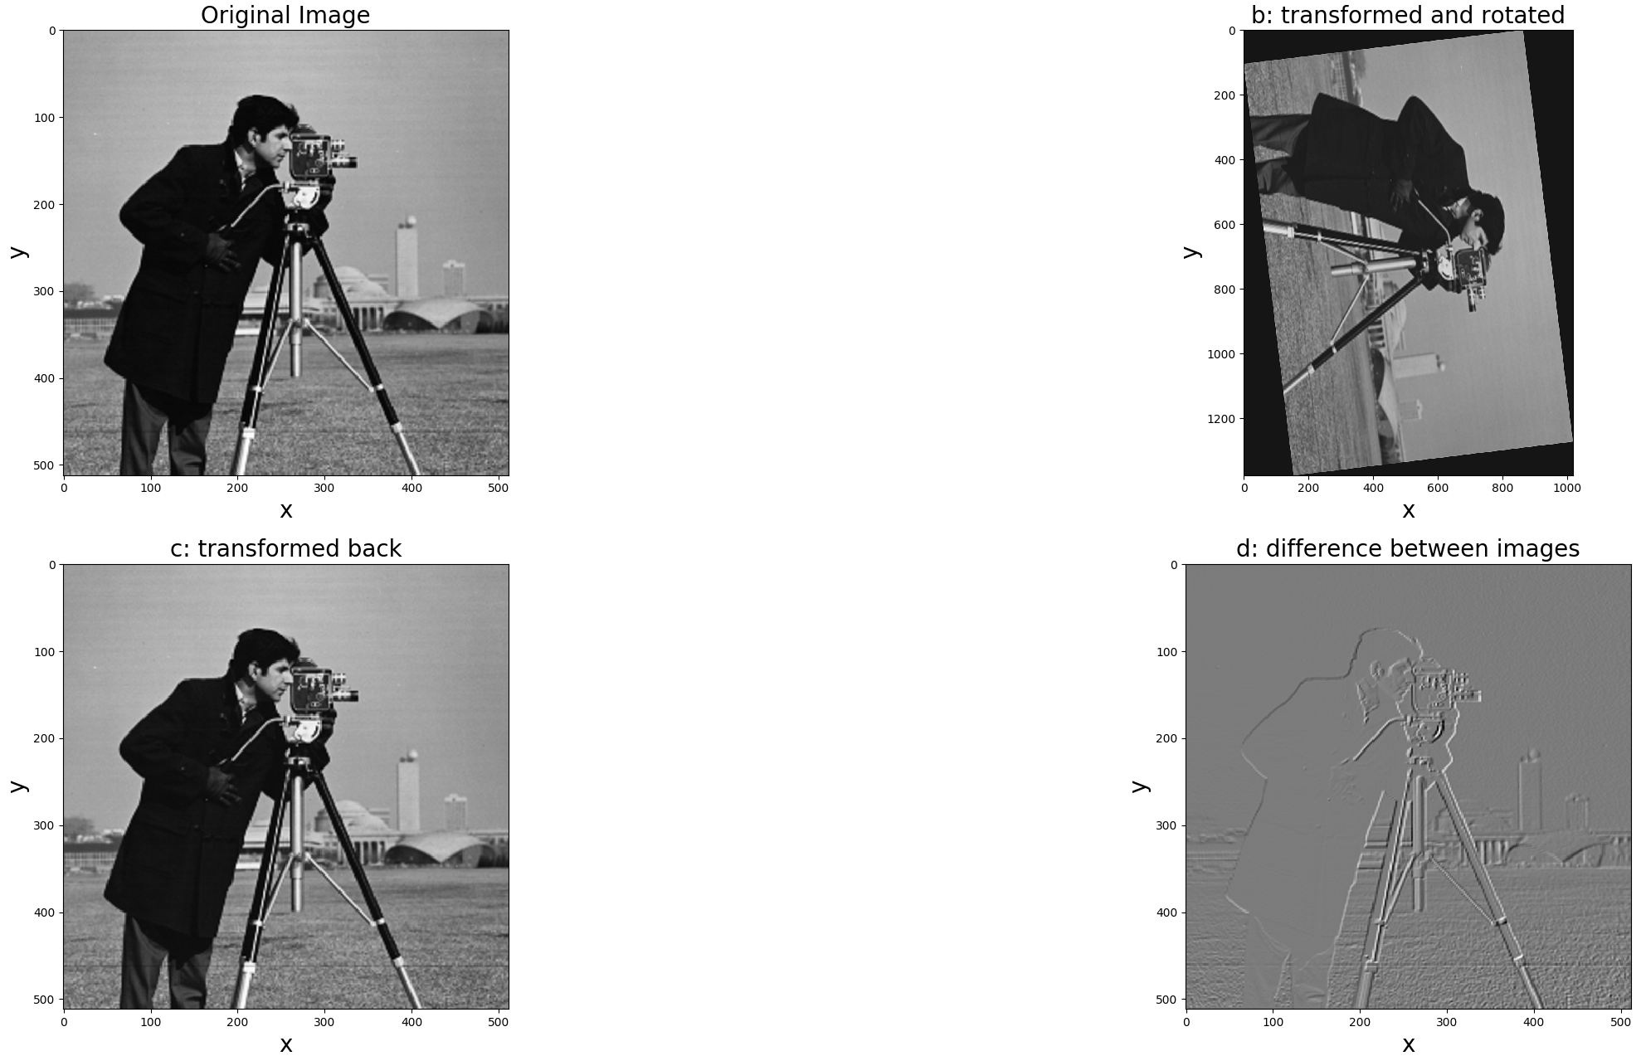

(a) py-file with a well-commented code.
Code attached
(b) Show the result when the input image is enlarged by 2.5 along rows, shrunk by 1.7 along
columns, and rotated by 27.5 degrees clockwise.
Top Right Image
(c) Show the inverse transform of the resulting image in (b).
Bottom Left Image
(d) Show the difference between the original(input) image and the image obtained in (c).
Bottom Right Image
(e) Calculate PSNR of the image obtain in (c) compared to the original image.
PSNR = PSNR: 25.623982810977193
# CODE Q2
import dippykit as dip
import numpy as np
# The Function for Q2 is defined here
# Takes in the image and parameters (rowise scaling, columnwise scaling, and rotation)
# The function is overloaded so that inputing the original size will do the inverse transform
def transform(img, rows, cols, rot, size=None):
s = np.sin(rot*180/np.pi) # Sin(theta)
c = np.cos(rot*180/np.pi) # Cos(theta)
r = np.array([[c, -s], [s, c]]) # Rotation Matrix
m = np.array([[(1/rows), 0], [0, (1/cols)]]) # Sampling matrix
# If doing a regular transformation, resize the image then rotate
if size is None:
img = dip.resample(img, m, interpolation='bicubic')
return dip.resample(img, r, interpolation='bicubic')
# If doing an inverse transformation, rotate image then resize
else:
img = dip.resample(img, r, interpolation='bicubic')
return dip.resample(img, m, crop=True, crop_size=size, interpolation='bicubic')
# Read in the image
X = dip.im_read('images/cameraman.tif')
X = dip.im_to_float(X)
# Transform image
Xnew = transform(X, 2.5, 1.7, 27.5)
# Inverse transformation
Xre = transform(Xnew, 1/2.5, 1/1.7, -27.5, np.shape(X))
# Difference between original and new
Xdif = X-Xre
# Create a subplot, display the original image
dip.subplot(2, 2, 1)
dip.xlabel('x', fontsize=20)
dip.ylabel('y', fontsize=20)
dip.title('Original Image', fontsize=20)
dip.imshow(X, cmap='gray')
# Display transformed image
dip.subplot(2, 2, 2)
dip.xlabel('x', fontsize=20)
dip.ylabel('y', fontsize=20)
dip.title('b: transformed and rotated', fontsize=20)
dip.imshow(Xnew, cmap='gray')
# Display recreated image
dip.subplot(2, 2, 3)
dip.xlabel('x', fontsize=20)
dip.ylabel('y', fontsize=20)
dip.title('c: transformed back', fontsize=20)
dip.imshow(Xre, cmap='gray')
# Display the difference between images
dip.subplot(2, 2, 4)
dip.xlabel('x', fontsize=20)
dip.ylabel('y', fontsize=20)
dip.title('d: difference between images', fontsize=20)
dip.imshow(Xdif, cmap='gray')
# Calculate PSNR
print(dip.PSNR(X, Xre, 1))
# Show plots and finish
dip.show()

Question 4
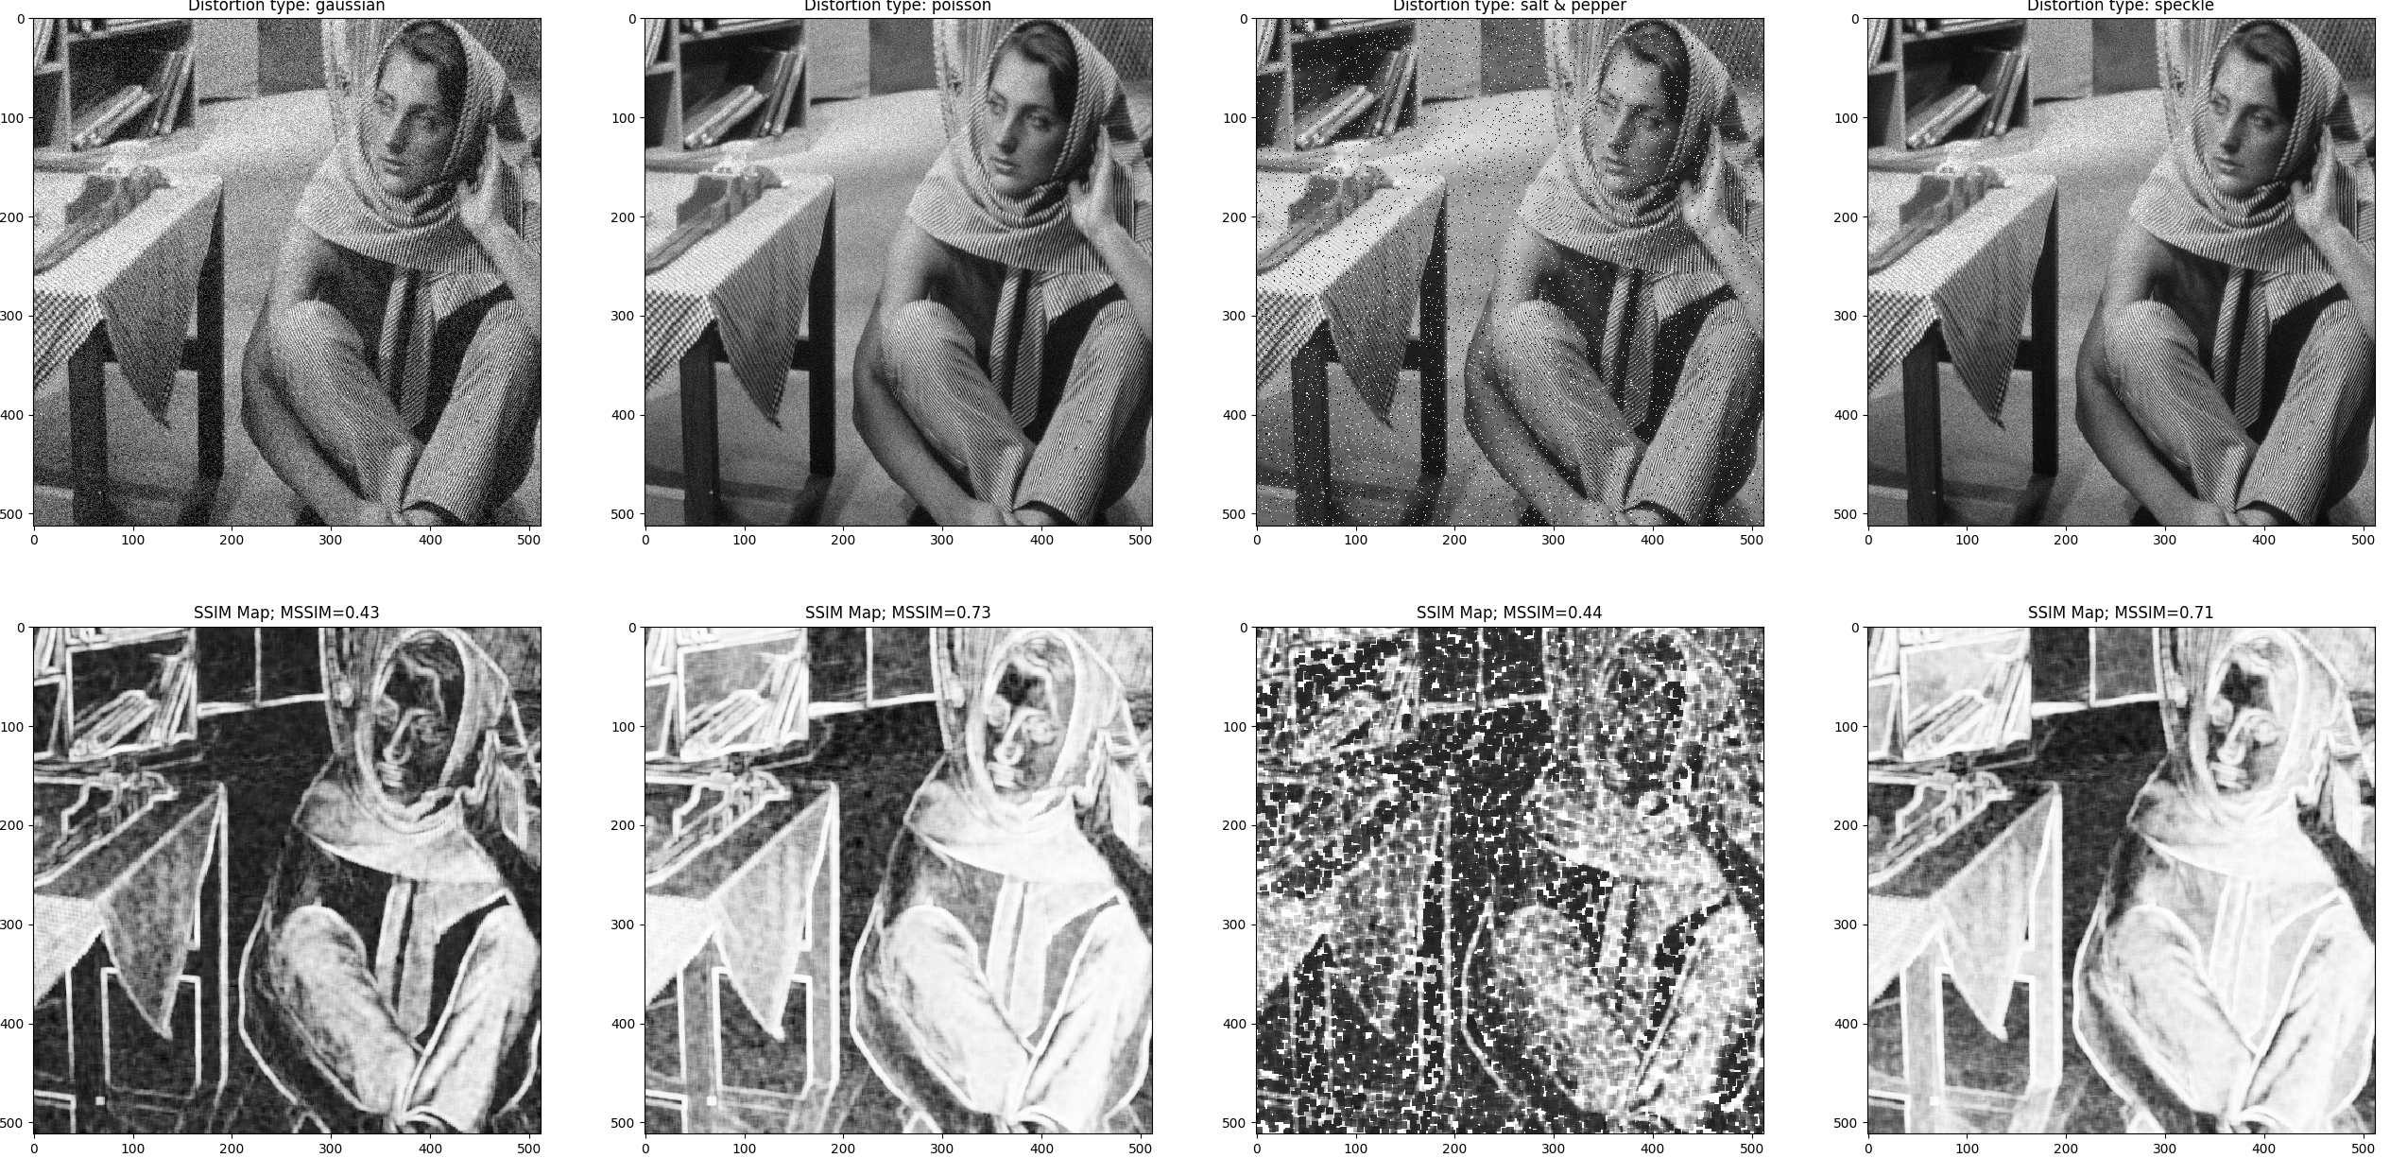

(a) Unzip the file ch06 ssim.zip and verify its content. It should include ch06 run me ssim.py
file.
(b) Read the image barbara.png from the images folder provided on the course website.
(c) Use the image noise function to add Gaussian noise to the image (use default parame-
ters).
(d) Use image noise function to add Poisson noise to the image (use default parameters).
(e) Use image noise function to add salt and pepper noise to the image (use default param-
eters).
(f) Use image noise function to add speckle noise to the image (use default parameters).
(g) Use SSIM function to obtain MSSIM values and SSIM maps of the distorted images
(h) Report MSSIM values for each of the distorted image and show the results.

Gaussian | MSSIM = 0.43
Poisson | MSSIM = 0.73
Salt & Pepper | MSSIM = 0.45
Speckle | MSSIM = 0.71

#CODE Q4
import numpy as np
import dippykit as dip
# Read the image
# ============================ EDIT THIS PART =============================
im = dip.im_read('images/barbara.png')
# Add noise to the original image to create new images
# ============================ EDIT THIS PART =============================
im_gaussian = dip.image_noise(im, 'gaussian')
im_poisson = dip.image_noise(im, 'poisson')
im_salt_pepper = dip.image_noise(im,'s&p')
im_speckle = dip.image_noise(im, 'speckle')
# Compute the SSIM values and images
# ============================ EDIT THIS PART =============================
mssim_gaussian, ssim_image_gaussian = dip.SSIM(im, im_gaussian)
mssim_poisson, ssim_image_poisson = dip.SSIM(im, im_poisson)
mssim_salt_pepper, ssim_image_salt_pepper = dip.SSIM(im, im_salt_pepper)
mssim_speckle, ssim_image_speckle = dip.SSIM(im, im_speckle)
dip.figure()
dip.subplot(2, 4, 1)
dip.imshow(im_gaussian, 'gray')
dip.title('Distortion type: gaussian')
dip.subplot(2, 4, 2)
dip.imshow(im_poisson, 'gray')
dip.title('Distortion type: poisson')
dip.subplot(2, 4, 3)
dip.imshow(im_salt_pepper, 'gray')
dip.title('Distortion type: salt & pepper')
dip.subplot(2, 4, 4)
dip.imshow(im_speckle, 'gray')
dip.title('Distortion type: speckle')
dip.subplot(2, 4, 5)
dip.imshow(ssim_image_gaussian, 'gray')
dip.title('SSIM Map; MSSIM={0:.2f}'
.format(mssim_gaussian))
dip.subplot(2, 4, 6)
dip.imshow(ssim_image_poisson, 'gray')
dip.title('SSIM Map; MSSIM={0:.2f}'
.format(mssim_poisson))
dip.subplot(2, 4, 7)
dip.imshow(ssim_image_salt_pepper, 'gray')
dip.title('SSIM Map; MSSIM={0:.2f}'
.format(mssim_salt_pepper))
dip.subplot(2, 4, 8)
dip.imshow(ssim_image_speckle, 'gray')
dip.title('SSIM Map; MSSIM={0:.2f}'
.format(mssim_speckle))
dip.show()

